Supervised Machine Learning
Decision Tree
A Decision Tree is a supervised machine-learning algorithm for classification and regression tasks. It models data using a tree-like structure, where each internal node represents a decision based on an attribute, each branch represents an outcome of that decision, and each leaf node represents a final class label or numerical value.
- Decision trees are a popular machine learning algorithm used for classification and regression tasks.

- They are structured like a tree, where each internal node represents a "test" or "decision" on an attribute,

- and each leaf node represents a class label or a predicted value.
The two most widely known decision tree algorithms are
- CART (Classification and Regression Trees)-Gini Index and
- ID3 (Iterative Dichotomiser 3)-Entropy, Information Gain .

They differ in the way they build the tree and the criteria they use for making splits.

A classic famous example where a decision tree is used is known as
Play Tennis.

Think of decision trees as if-or-else rules where each if-else condition leads to a specific answer at the end.
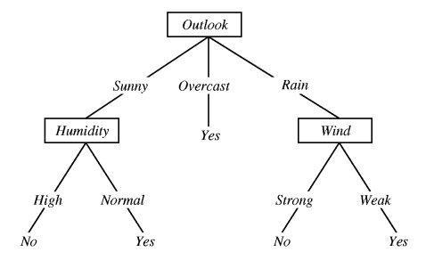

- If the Outlook is Sunny and Humidity is Normal, then
“yes”, you may play tennis.

- If the Outlook is Rain and the Wind is Strong, then?

Suppose we get a new instance
Outlook =Sunny, Temperature=Hot, Humidity=High, Wind=Strong
How do we classify it?

Dataset
Outlook | Temperature | Humidity | Wind | Play (Tennis)
Sunny | Hot | High | Weak | No
Sunny | Hot | High | Strong | No
Overcast | Hot | High | Weak | Yes
Rain | Mild | High | Weak | Yes
Rain | Cold | Normal | Weak | Yes
Rain | Cold | Normal | Strong | No
Overcast | Cold | Normal | Strong | Yes
Sunny | Mild | High | Weak | No
Sunny | Cold | Normal | Weak | Yes
Rain | Mild | Normal | Weak | Yes
Sunny | Mild | Normal | Strong | Yes
Overcast | Mild | High | Strong | Yes
Overcast | Hot | Normal | Weak | Yes
Rain | Mild | High | Strong | No

- No. of samples/ records?
- Positive records & Negative records?
- No. of Features?
- What are the Features?
- Outlook unique values-
- Temperature unique values-
- Humidity unique values
- Wind unique values
- Target?

- No. of samples/ records 🡪14
- Positive records & Negative records🡪9,5 resp.
- No. of Features 🡪4
- What are the Features🡪 Outlook, temperature, Humidity, Wind
- Outlook unique values🡪3 (Overcast, Sunny, Rainy)
- Temperature unique values🡪3(Cool, Mild, Hot)
- Humidity unique values🡪2 (Normal, High)
- Wind unique values🡪2 (Weak, Strong)
- Target🡪2 (Yes, No)
Let's solve using ID3- Entropy and Information Gain (IG)
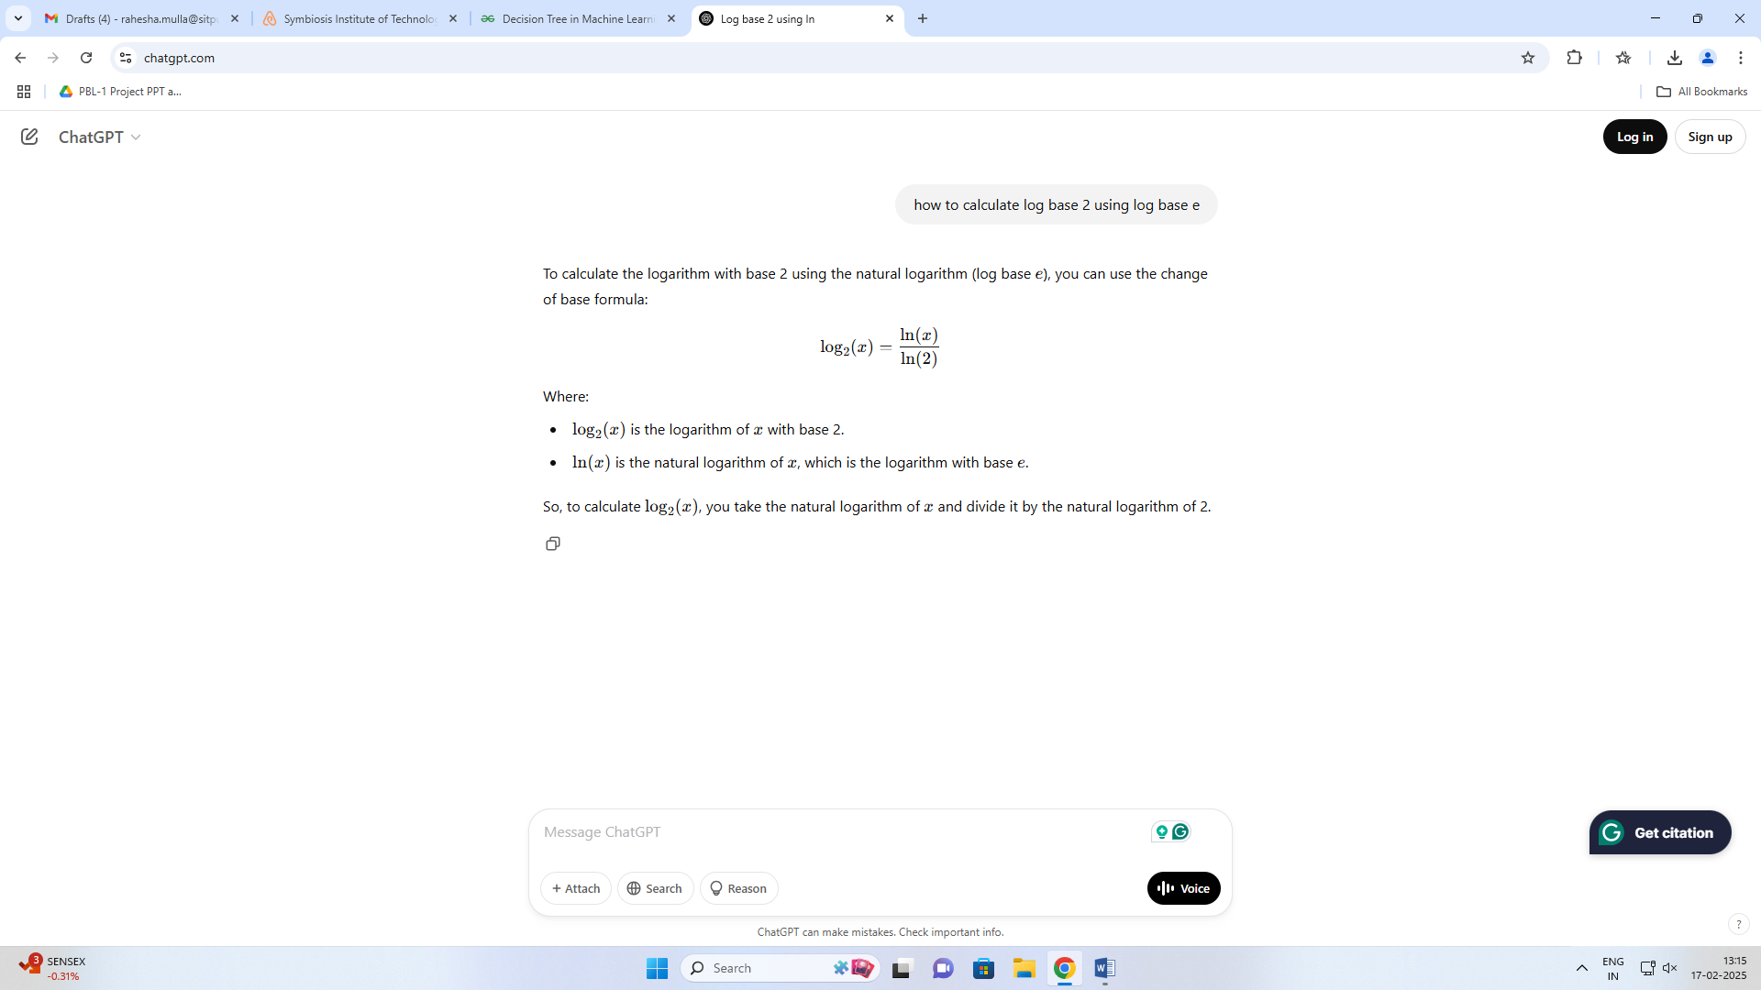
Entropy is used to measure the uncertainty or impurity of the dataset.
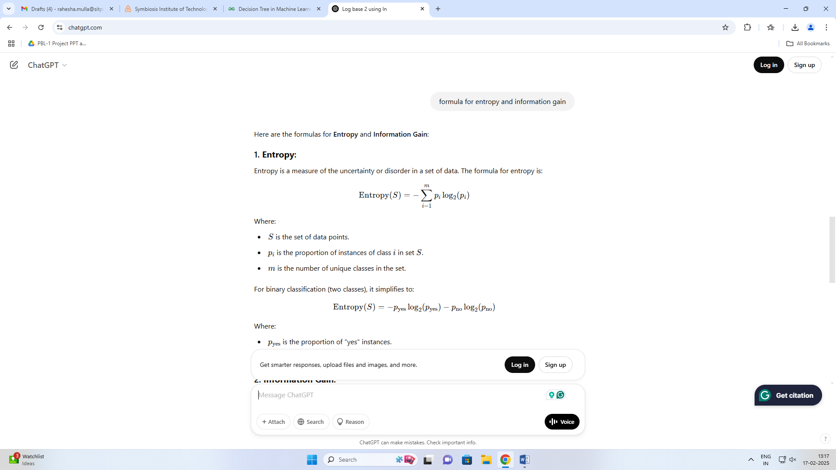
Where:
- S is the set of data points.
- p_{i} is the proportion of instances of class i in set S
- m is the number of unique classes in the set.

Play (Tennis) (14) | Yes | No
 | 9 | 5
`
Outlook (14) | Sunny (5) |  | Overcast (4) |  | Rain (5)
 | Yes | No | Yes | No | Yes | No
 | 2 | 3 | 4 | 0 | 3 | 2

Do it for
Temperature
(14)

Humidity
(14)

wind
(14)

Outlook (14) | Sunny (5) |  | Overcast (4) |  | Rain (5)
 | Yes | No | Yes | No | Yes | No
 | 2 | 3 | 4 | 0 | 3 | 2

Temperature  (14) | Hot (4) |  | Mild (6) |  | Cold (4)
 | Yes | No | Yes | No | Yes | No
 | 2 | 2 | 4 | 2 | 3 | 1

Humidity  (14) | High (7) |  | Normal (7)
 | Yes | No | Yes | No
 | 3 | 4 | 6 | 1

wind  (14) | Weak (8) |  | Strong (6)
 | Yes | No | Yes | No
 | 6 | 2 | 3 | 3

Step 1: Calculate the entropy of the target variable (Play Tennis)
- The total number of examples is 14.
- The number of positive examples (Play Tennis = Yes) is 9, and the number of negative examples (Play Tennis = No) is 5.

Entropy (Play Tennis) = - (9/14) * log2(9/14) - (5/14) * log2(5/14)
= 0.940

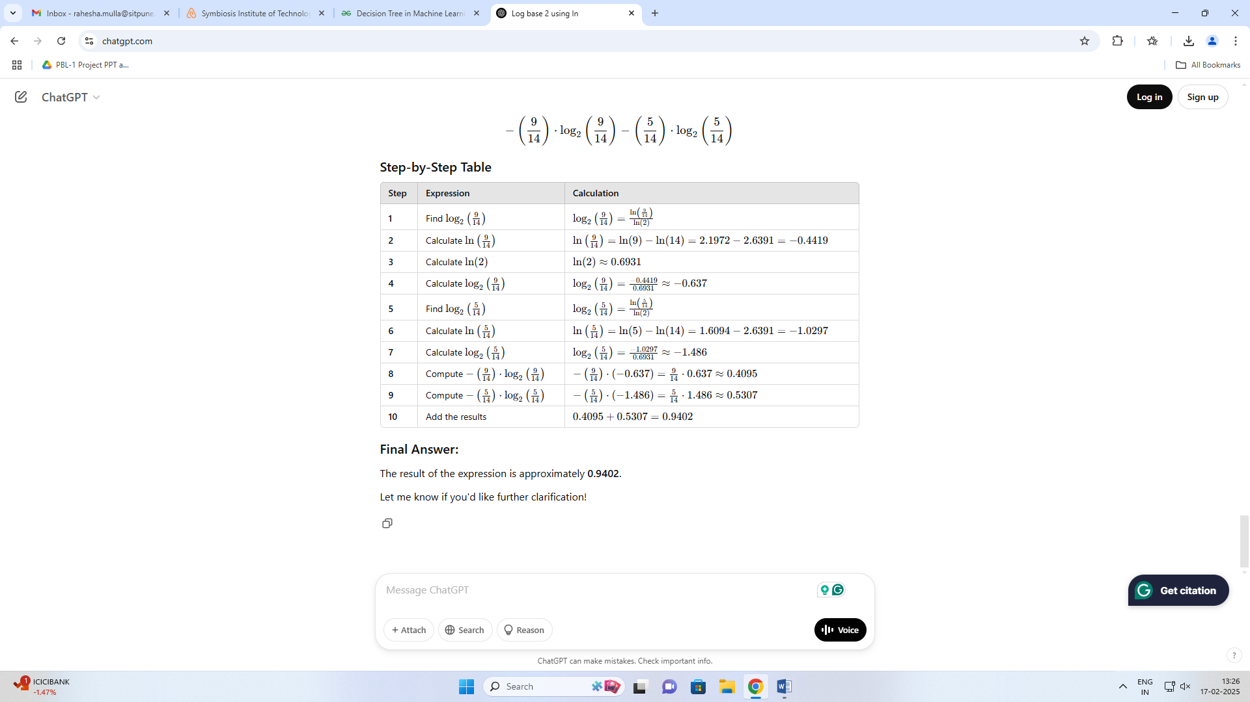

Step 2: Calculate the entropy of each Feature (Outlook, Temperature, Humidity, Wind)
Outlook (14) | Sunny (5) |  | Overcast (4) |  | Rain (5)
 | Yes | No | Yes | No | Yes | No
 | 2 | 3 | 4 | 0 | 3 | 2

Entropy (Play Tennis | Outlook=Sunny)
= - (2/5) * log2(2/5) - (3/5) * log2(3/5)
= 0.971

Entropy (Play Tennis | Outlook=Overcast)
= - (4/4) * log2(4/4) - (0/4) * log2(0/4)
= 0.0

Entropy (Play Tennis | Outlook=Rain)
= - (3/5) * log2(3/5) - (2/5) * log2(2/5)
= 0.971

Outlook:
- Entropy (Play Tennis | Outlook = Sunny) = 0.971
- Entropy (Play Tennis | Outlook = Overcast) = 0.0
- Entropy (Play Tennis | Outlook = Rain) = 0.971

Do it for
Temperature, Humidity, Wind

Outlook:
- Entropy (Play Tennis | Outlook = Sunny) = 0.971
- Entropy (Play Tennis | Outlook = Overcast) = 0.0
- Entropy (Play Tennis | Outlook = Rain) = 0.971

Temperature:
- Entropy (Play Tennis | Temperature = Hot) = 1.0
- Entropy (Play Tennis | Temperature = Mild) = 0.918
- Entropy (Play Tennis | Temperature = Cold) = 0.811

Humidity:
- Entropy (Play Tennis | Humidity = High) = 0.985
- Entropy (Play Tennis | Humidity = Normal) = 0.591
Wind:
- Entropy (Play Tennis | Wind = Weak) = 0.811
- Entropy (Play Tennis | Wind = Strong) = 1.0

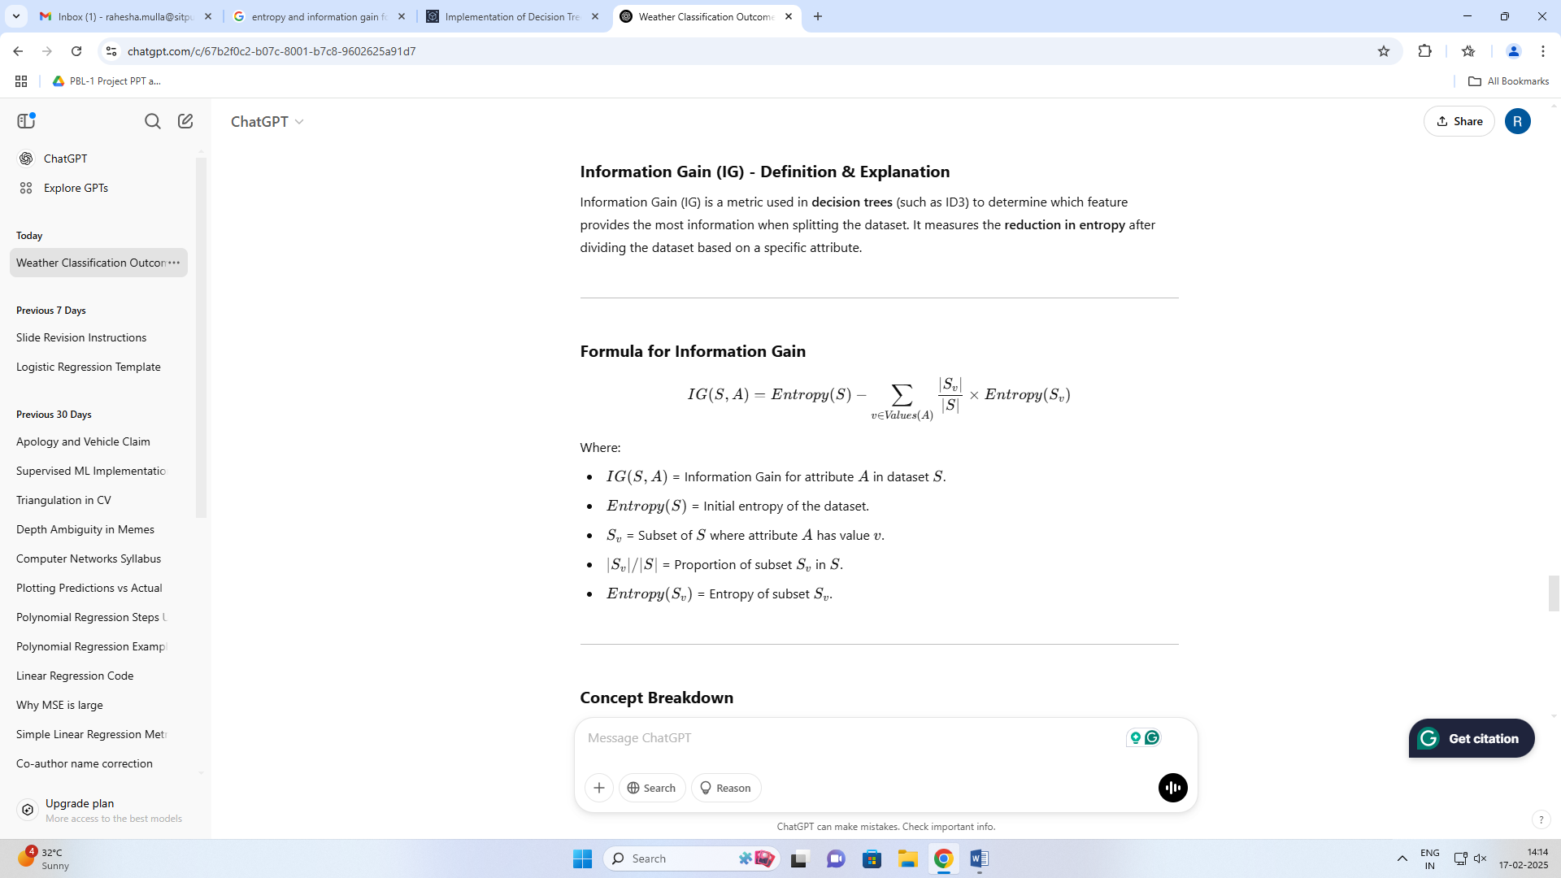

Step 2: Calculate the Information Gain for each feature
IG(Outlook) = Entropy (Play Tennis) - [(5/14) * Entropy (Play Tennis | Outlook = Sunny) + (4/14) * Entropy (Play Tennis | Outlook = Overcast) + (5/14) * Entropy (Play Tennis | Outlook = Rain)]
= 0.940 -[(5/14)*0.971 + (4/14)* 0.0 +(5/14) * 0.971]
= 0.246
Do it for
IG(Temperature)
IG(Humidity)
IG(Wind)

IG(Temperature) = Entropy (Play Tennis) - [(4/14) * Entropy (Play Tennis | Temperature = Hot) + (4/14) * Entropy (Play Tennis | Temperature = Mild) + (6/14) * Entropy (Play Tennis | Temperature = Cold)]
= 0.940 -[(4/14) * 1.0+(4/14)* 0.918+(6/14) * 0.811]
= 0.029
IG(Humidity) = Entropy (Play Tennis) - [(7/14) * Entropy (Play Tennis | Humidity = High) + (7/14) * Entropy (Play Tennis | Humidity = Normal)]
= 0.940 - [(7/14) * 0.985 + (7/14) * 0.591]
= 0.152
IG(Wind) = Entropy (Play Tennis) - [(8/14) * Entropy (Play Tennis | Wind = Weak) + (6/14) * Entropy (Play Tennis | Wind = Strong)]
= 0.940 - [(8/14) * 0.811 + (6/14) * 1.0]
= 0.048

Based on these calculations, we can see that the Outlook feature has the highest IG, followed by Wind, Temperature, and Humidity. Therefore, Outlook would be the best feature to split the dataset on first when creating a decision tree.

Step 3: Conclusion
The Information Gain (IG) for each feature:
- Outlook: 0.246
- Temperature: 0.029
- Humidity: 0.152
- Wind: 0.048
Since Outlook has the highest IG (0.246), it is the best feature to split on first when constructing the decision tree.

Decision Tree:
Based on the Information Gain calculations, we can create a decision tree as follows:
Outlook
/ | \
Sunny Overcast Rainy
/ | \
Humidity Yes Wind
/ \
Wind No
|
Yes

Here, the first split is on the Outlook feature, since it has the highest IG. If the Outlook is Sunny, we check the Humidity feature next, and if the Humidity is High, we predict No, otherwise Yes. If the Outlook is Overcast, we predict Yes. If the Outlook is Rainy, we check the Wind feature next, and if the Wind is Weak, we predict Yes, otherwise No.
This is a general example and could not be the best decision tree, a best decision tree may vary with a real given dataset.
Overall, Decision Trees are a powerful and versatile machine learning algorithm that can be used for a wide range of tasks. They are particularly useful when the data is non-parametric, contains missing values, or has complex relationships between the input variables.

